House Bill 180

Delaware Civics Standard 4, Grades 6-8

by

Fran O’Malley
Democracy Project
Institute for Public Administration
University of Delaware

House Bill 180

by

Fran O’Malley
Democracy Project
Institute for Public Administration, University of Delaware

Lesson Description: This lesson features a mock election that pits two candidates with very different positions on a debate over homework. Students cast their votes fully aware of the positions of both candidates but learn why citizens in a democratic society should remain informed after an election when the winner pulls a 180̊ turnaround following the election.

Time Required: approximately 50-60 minutes (may be desirable to spread out over 2 days – see Procedures).

Content Sequencing: Civics Standard 4 for grades 4-5 anticipates that students will develop an understanding of the need to become informed when choosing between candidates for office. “The Election” lesson for grades 4-5at www.ipa.udel.edu/democracy/resources/lessonplans.html a nurtures this understanding.

Civics 4 for grades 6-8 advances this understanding by highlighting the need for citizens to remain informed after elections take place.

Benchmark Addressed: Civics 4, Grades 6-8.
Students will follow the actions of elected officials, and understand and employ the mechanisms for communicating with them while in office.
Essential Question Addressed: Why should citizens remained informed after candidates are elected to office?
Enduring Understanding: The well-being of a democratic society rests significantly on citizens who remain vigilant.

Materials:
- Handout #1: Candidate Information.
- Handout #2: Election Ballots.
- Handout #3: House Bill #180.

Procedures:

Phase 1
- Tell students that you are going to conduct a mock election involving hypothetical candidates for the state legislature. The purpose is to get them to think about the need to be attentive to the qualifications of candidates as well as their positions on the issues.

- Explain to the class that the key issue in this election is education and that the main point of controversy involves homework requirements.
- Distribute copies of Handout #1: Candidate Information to the students. Ask them to read about both candidates and decide which one they will support with explanations as to why they support a particular candidate.

- Solicit feedback from the students e.g. who is the best candidate and why? Which was most important– the candidates’ qualifications or their positions on the main issue in the campaign?

- Distribute copies of the ballots on Handout #2: Election Ballots. Ask the students to cast their ballots and announce the winner.

Let some time pass before Phase 2 (or Day 2) of the lesson so that students undergo an experience similar to that which a voter would after an election. In other words, give the students time to be lulled into a sense of security and inaction.

Phase 2
- Review the previous day’s lesson. Ask students: what was the main activity? What was the purpose of the activity? Who won? Were most of you satisfied with the results of the election? Did the best candidate win?

- Tell students that the state legislature convened and a series of bills were introduced. Distribute copies of Handout #3: House Bill #180 and ask the students to read House Bill #180.

IMPORTANT – there are two copies of House Bill #180. Distribute House Bill 3a if Candidate A – Ms. Michelle Jackson - wins the election. Distribute House Bill 3b if Candidate B – Mr. Ryan Diaz - wins the election.

- For the Teacher: The contents of the bill designed for each candidate represents a complete turnaround (180̊) in terms of the position the candidate took BEFORE the election…while running for office. Recall what the central understanding (see benchmark and essential question) for which this lesson is designed i.e. that students should understand that citizens should remain informed i.e. after a representative has been elected.

- Ask a volunteer to summarize House Bill #180. Call on others to describe their reactions to the bill. Ask the students…
  - How do they feel about the actions of the person who they elected to be their representative? Explain why.
  - Is the newly elected representative representing those who elected him or her effectively?
  - How should students respond when elected representatives ignore the wishes of those who elected them? [remind students that the representative would still have a considerable amount of time left in his or her term]

- For the Teacher: This may be a perfect time to revisit the understanding nurtured in Civics Standard 1 at grades K-3. An essential question addressed at that time was: how should a representative represent you? The understanding is that representatives wear 2 hats. At times they wear the hat of a trustee (assumes that the electors place trust in the representative to use his or her good judgment), while at other times they wear their instructed delegate hat (assumes that a representative should follow the instructions of his or her constituents). Review difference between the trustee and instructed delegate theories of representation then ask…
  - Which hat was the representative wearing when he or she introduced House Bill 180̊?
  - Was this a legitimate situation in which to wear that hat or is House Bill 180̊ an example of abuse?

- Think-Pair-Share: Tell students that an initial response to situations in which citizens believe that their elected officials are performing poorly is to communicate their displeasure or grievances and request a change. The important thing is to consider which way would be the effective way to communicate with elected officials. Ask students to take 60 seconds to generate a list of ways that a person could communicate with elected officials (e.g. face to face meeting, e-mail, handwritten letter, typed letter, phone call etc.). Ask volunteers to share one method on their list and post them on the board. Continue to gather responses not yet offered.

- Group Work: place students in small groups of 3-4 and assign each group one method of communication with elected officials. Tell them that their task is to analyze the positive and negative aspects of the method to which they’ve been assigned.

Debrief:
- Make it clear to students that House Bill #180 is not real.
- Ask the students:
  - How should citizens respond when events like t his occur?
  - Why should citizens remain informed after candidates are elected to office?
Handout 1
Candidate Information
Ms. Michelle Jackson
Candidate A

Biographical Information: Age: 37. Married with 2 children. President of Local School Board. Job: Attorney. Education: University Graduate. Community Work: Coaches community soccer team and volunteers at the local food bank.

Position Statement – Ms. Michelle Jackson
The stress that we have placed on teachers and students has increased significantly in recent years. Students and teachers are now asked to do more than at any other time in our nation’s history. The result has been that the joy of learning has been sucked out of our schools. Youth is a time for family, exercise and play. Time outside of school should be reserved for teachers, children, and their families to enjoy life and rejuvenate their desires to teach and learn. The formal academic development of a child should occur within school time while the time outside of school should be reserved for informal but equally important development that centers on family activities. Meanwhile, teachers should spend after school hours preparing engaging lessons rather than being burdened with grading homework every night. Our schools will be better if we end homework.

Mr. Ryan Diaz
Candidate B

Biographical Information: Age: 36. Married with 3 children. Head of community civic association. Job: Vice President of a Bank. Education: University Graduate. Community Work: Coaches a youth basketball team and is a volunteer scout leader.

Position Statement – Mr. Ryan Diaz
Students in our state perform poorly when compared to students in other countries taking the same international tests. Those same international tests show that American students spend less time in school than students in the best performing countries – sometimes as many as 50 less days! What does not get done in school has to be done at home. Homework must be required in this state or we need to increase the number of days that our students attend school. Otherwise, the companies that bring jobs to our citizens will leave the state and relocate to a country that graduates better students.
Handout 2:
Election Ballots

Election Ballot  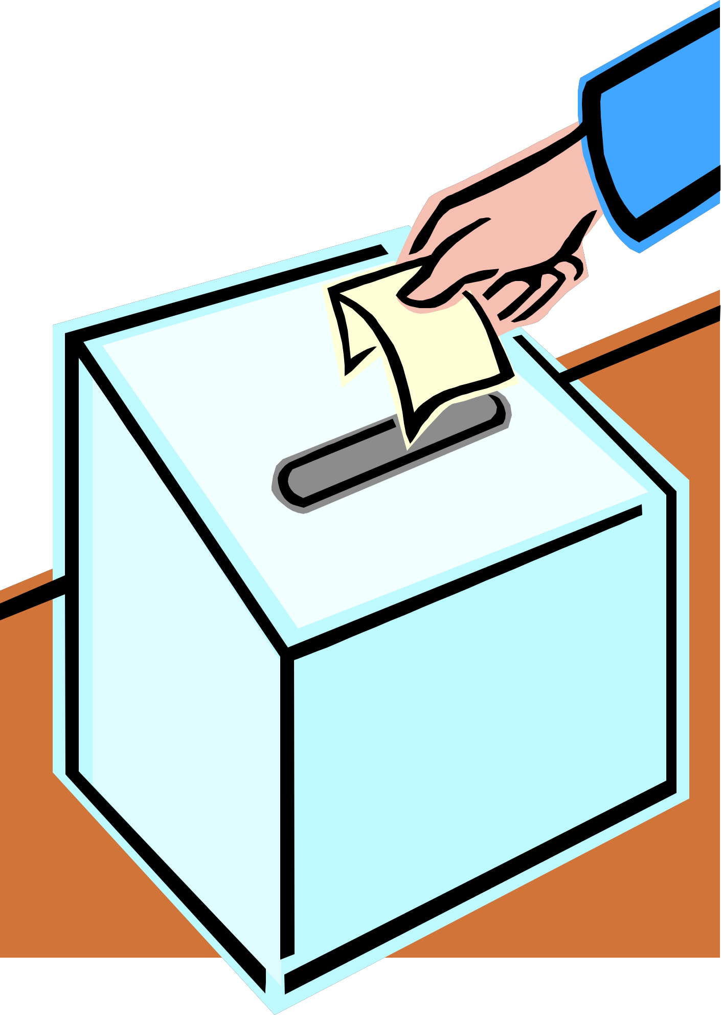  Place a check next to the candidate for whom you wish to vote. Vote for one candidate only.  ____ Michelle Jackson  ____ Ryan Diaz | Election Ballot  Place a check next to the candidate for whom you wish to vote. Vote for one candidate only.  ____ Michelle Jackson  ____ Ryan Diaz | Election Ballot  Place a check next to the candidate for whom you wish to vote. Vote for one candidate only.  ____ Michelle Jackson  ____ Ryan Diaz

Election Ballot  Place a check next to the candidate for whom you wish to vote. Vote for one candidate only.  ____ Michelle Jackson  ____ Ryan Diaz | Election Ballot  Place a check next to the candidate for whom you wish to vote. Vote for one candidate only.  ____ Michelle Jackson  ____ Ryan Diaz | Election Ballot  Place a check next to the candidate for whom you wish to vote. Vote for one candidate only.  ____ Michelle Jackson  ____ Ryan Diaz

Handout 3a
House Bill #180a

Sponsor: Rep. Michelle Jackson

Delaware State Legislature

An Act to improve all K-12 schools throughout the state; specifying homework requirements.

(1) Whereas a key factor determining the academic success of a student

(2) is the amount of instructional time they receive; and, given the fact that other countries

(3) whose students perform better on international tests require their students to attend up to

(4) 40 more days of school during the year;

(5) Noting that our the ability of our state to compete in the highly competitive global

(6) economy of the 21st Century hinges upon the abilities of those who graduate from our

(7) schools;

(8) Section 1 (a) Be it enacted that students attending schools within the State

(9) shall be assigned a minimum of 10 minutes of homework per night beginning in grade 1.

(10) For each grade that follows, students share be assigned an additional 10 minutes of

(11) homework.

(12) Section 2 (b) House Bill 180 shall go into effect at the beginning of the next

(13) school year.

- End -
Handout 3b
House Bill #180b

Sponsor: Rep. Ryan Diaz

Delaware State Legislature

An Act to improve all K-12 schools throughout the state; specifying homework guidelines.

(1) Whereas students spend the better part of 180 days of their lives sitting in

(2) classrooms;

(3) And, whereas the research on the benefits of homework is conflicting while the

(4) benefits of setting aside time outside of school for family building and exercise are

(5) unchallenged;

(6) Section 1 (a) Be it enacted that homework shall be prohibited in schools

(7) throughout the state.

(8) Section 2 (b) House Bill 180 shall go into effect next school year.

- end -

Handout 4
Analyzing Methods of Communication

Method
_________________________________

Positive Aspects of the Method | Negative Aspects of the Method

- Describe the characteristics of the type of person for whom this would be an effective means of communication.

- Describe the characteristics of the type of person for whom this would not be an effective means of communication.

