Social Studies Home Learning Activities

Standard Benchmark  Civics 3a | Students will apply the fundamental rights and protections of American citizens guaranteed in the Bill of Rights to everyday situations.
Grade Band | 4-5
Vocabulary/Key Concepts | Apply, Bill of Rights, constitutional, unconstitutional, assemble

The Constitutional Chronicles of Gabi Grosera

Activity 1: Read - Understanding Our Rights as American Citizens
The Bill of Rights were added to the United States Constitution to protect the individual rights of American citizens from the enormous powers that our Founding Fathers granted to our national government. They feared that government might use some of its powers to take away people’s rights. Some of the protections in the Bill of Rights guarantee us freedom of speech, religion, and the press. Others guarantee citizens the rights to petition our government, to share our written opinions in newspapers, and to assemble or gather together with other people to share ideas peaceably.
American citizens are very lucky to have these rights and protections.
But some people think that these rights have no limits. For example, some people think that, since we have freedom of speech, we can say anything we want.
The fact is, there are limits to what we can say or do even if the Constitution lists what we say or do as our rights. The word for this is “scope”. The word scope is used to describe how far we have the right to do or say something before it gets to the point where we are no longer allowed to do it. If there are no limits on our rights, people can get hurt.
- Can you think of an example that describes someone exercising a right in a way that causes someone else to get hurt?

Sometimes people do or say things because they believe that they have a right to do or say them. But, people with authority sometimes have to step in and order them to stop. Sometimes those with authority are even allowed to punish citizens for doing and saying things even though they are listed as our rights.
Luckily, the Bill of Rights also guarantees American citizens the right to a fair trial. People who believe that they have been wrongly accused or punished can “take their case to court”. A judge can then decide whether the actions taken by government officials were constitutional (allowed under our Constitution) or unconstitutional (not allowed under our Constitution). If the accusations and punishments are unconstitutional, the person who has been accused is considered innocent and cannot be punished.

Check for Understanding
- Which rights of American citizens are described in the reading?
_______________________________________________________________________________________________________________________________________________________________________________________

- What does it mean when someone says that our rights have “scope”?
__________________________________________________________________________________________________________________________
- Why are there limits on our rights as American citizens?
_______________________________________________________________________________________________________________________________________________________________________________________

Activity 2: You Be the Judge
There are four cases or “Chronicles” described below. Each chronicle describes actions taken by a fictional American citizen named Gabriela Grosera, and other actions taken by government officials – people with authority. Acting as judge, decide whether the actions taken by the government officials are constitutional or unconstitutional. Be sure to explain you decisions.

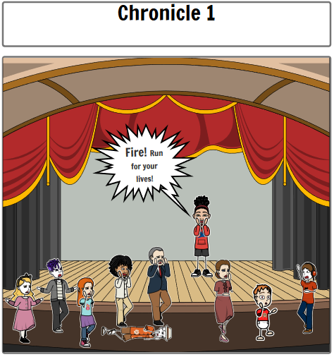
The Constitution guarantees American citizens the right to freedom of speech.

Gabriela Grosera went to the movies last Saturday. The theater was very crowded. Gabriela thought the movie was boring and wanted some excitement. She stood up and shouted, “FIRE” even though she knew that there was no fire. Everyone rushed to the doors to escape. The crowd knocked Gabi’s friend Ricky to the ground. Ricky suffered a very painful boo boo on his nose.

Government authorities took Ms. Grosera into custody and fined her $13. Gabi argues that the fine was unconstitutional because she has the right to free speech. Ricky disagreed.

Are the government’s actions constitutional or unconstitutional (circle one)?

Explain why: ___________________________________________________
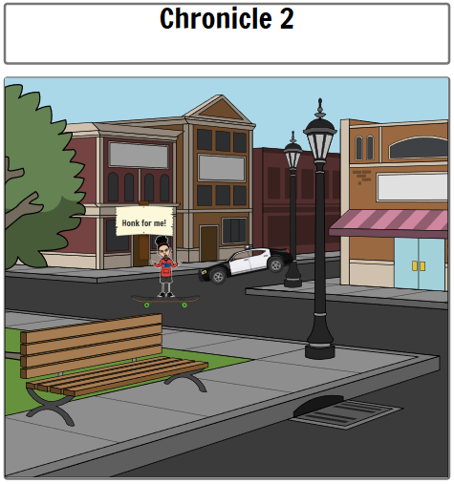

The Constitution guarantees American citizens the right to assemble peaceably.

Gabriela Grosera was upset because the city where she lives passed a law saying that it is illegal for children under the age of 12 to ride skateboards in the street. Gabi is 11 years old. She made a poster protesting the new law. It read, “I will ride my skatebored anywhere I want!” and stood in the middle of the street with her sign and skateboard shouting “honk your horn if you support me.” The first car to pass by was a police car. Ooops!

Officer Grunion removed Ms. Grosera from the street and fined her $13. Gabi argues that the fine was unconstitutional because she has the right to assemble peaceably.

Are the actions of the police constitutional or unconstitutional (circle one)?

Explain why: ___________________________________________________
_____________________________________________________________
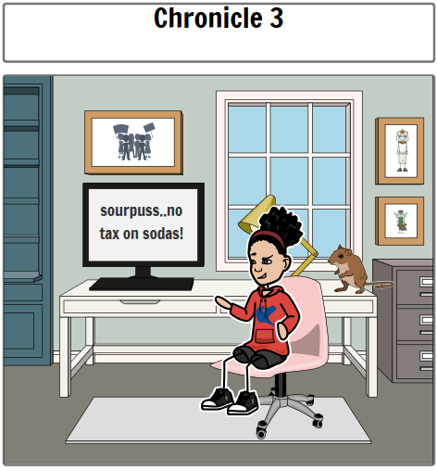

The Constitution guarantees American citizens the right to freedom of the press.

Gabriela Grosera is a very feisty young lady. After learning that the mayor of her city created a new tax on sodas, she wrote a letter to the local newspaper. The letter stated that the mayor was “a sourpuss who should be doing more importent things than putting taxes on my favorite bevrage.”

Authorities from the mayor’s office mailed Ms. Grosera a ticket for $13. It stated that she was fined for writing a letter that criticized “Mayor Sourpuss.”
Gabi argues that the fine was unconstitutional because she has the right to express her opinions in a newspaper.

Are the actions of the authorities constitutional or unconstitutional (circle one)?

Explain why: ___________________________________________________
_____________________________________________________________
__________________________________________________________________________________________________________________________

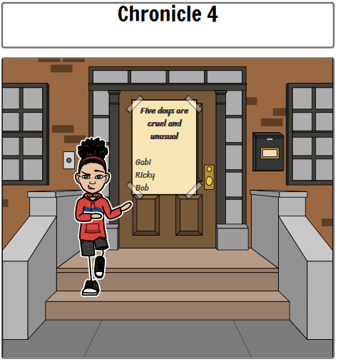

The Constitution guarantees American citizens the right to create a petition asking government officials to do or not do something.

Gabriela Grosera has some unusual ideas! She believes that children should only have to go to school one day per week. She created a petition demanding one day of school and got her only two friends to sign it. Gabi then glued the petition on the door of a local lawmaker’s home. She used a lot of glue (and tape)! The lawmaker had to replace her door, and had a hard time removing her hand from that door.

The next day Ms. Grosera received an official document stating that she had to go to court. On judgment day, Judge Amorduro ordered Gabriela to do community service. Specifically, she had to visit the local lawmaker’s house once a month for 13 months to polish her new door so that it would be nice and shiny.

Gabi argued quite boldly that the punishment was unconstitutional because the 1st Amendment states that she has the right to petition her government.

Are the actions of the judge constitutional or unconstitutional (circle one)?

Explain why: __________________________________________________

