Social Studies Home Learning Activities

Standard Benchmark  Civics 2 | Students will understand that respect for others, their opinions, and their property is a foundation of civil society in the United States.
Grade Band | K-3
Vocabulary/Key Concepts | Civil, respect, opinion, property

Do this, Don’t do that!

Activity 1: Reading

Respect is important. It involves treating other people in ways that make them feel good about themselves. We show respect when we treat other people the same way that we want them to treat us.
Why should we show respect? First, it is the right thing to do. Second, if you treat other people with respect, they will probably show you respect.
Also, places where people treat one another with respect are very nice places to live and go to school. They are places where everyone feels important. They are places where no one acts as if they are better than other people.

They are also places where we…

Do this… |  | Don’t do that…
Treat other people the same way you want to be treated |  | Be mean to people who are different
Are nice to people who have opinions that are different than your opinion. |  | Say mean things to those who have different opinions
Take care of property that does not belong to you |  | Take or damage property that belongs to other people

And, they are places where we…

Say this… |  | Don’t say that…
“I like how you are different.” |  | “You are really strange.”
“I disagree with you but I still like you.” |  | “That is really dumb.”
“I will be very careful with your property.” |  | “I don’t care what happens to it because it is not mine.”

- Describe one thing that you could do to show respect at home or at school.

I could do this ______________________________________
_________________________________________________

- Describe one thing that you could say to someone at home or at school to show respect.

I could say this _____________________________________
_________________________________________________

Activity 2: There are three cartoon scenes below. Read and look at each scene then…
- write down what a person who has respect would say or do
- write down what a person who does not have respect would say or do.

When you finish, ask yourself – why should people show respect for others, their opinions, and their property?

Scene 1
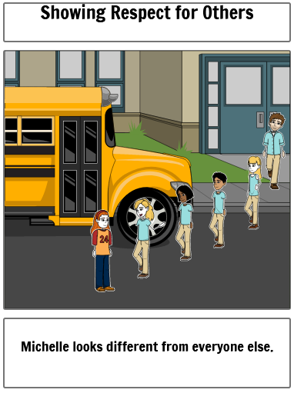

What Might the Students Say to Michelle to Show Respect for Her? | What Might Students Say that Would Not Show Respect for Michelle?

Scene 2
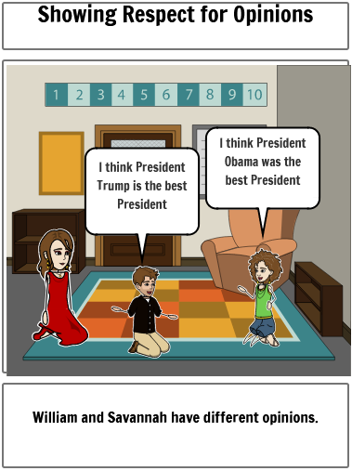

What Might a Person Say to William to Show Respect for Him? | What Might a Person Say that Would Not Show Respect for Him?

Scene 3
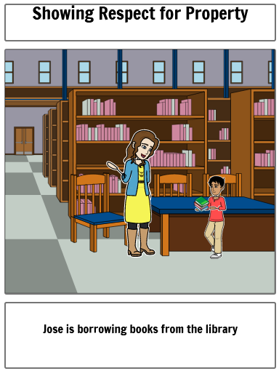

What Might Jose do to Show Respect for Property? | What Might Jose do that Would  Not Show Respect for Property?

