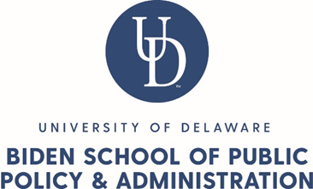

2022-2024 Program Educational Goals Collection (rev 9/2021)

This form is for collection program educational goals for the academic catalog. This form collects all the necessary data for your program to be entered into Curriculog.

Program Director and/or Program Committee’s Responsibilities: It is the Program Director and/or Program Committee’s responsibility to create and edit the content associated with this form and the attachments.

Graduate Services Coordinator Responsibilities: The Graduate Services Coordinator will provide administrative support, including answering questions, providing templates, providing clarifying information and entering the resulting content into the University tracking and approval system (Curriculog).

Please read all sections below.

ACADEMIC CATALOG
Undergraduate
Graduate

Department: Will default to Biden School

College/School: Will default to Biden School
- If other schools/colleges should be listed, please list here: Click or tap here to enter text.

Program Name:
Click or tap here to enter text.

Your email address: Click or tap here to enter text.

PROGRAM EDUCATIONAL GOALS

Please provide your Program Educational Goals in the space below.
Each degree-granting program has a unique set of educational goals. These goals are defined and assessed by the faculty in each program. They should:
- Clearly state the expected knowledge, skills, attitudes, competencies, and habits of mind that students are expected to acquire in the specific degree program.
- Appropriately incorporate and reinforce educational goals from the university, college(s), department(s), co-curricular activities, and appropriate disciplinary values.
- Reflect a course of study that is appropriately rigorous for the students admitted to the program.
- Reflect a course of study that students are able to complete within the average or a reasonable time-to-degree for that program.
If your program previously provided educational goals as part of the 2020 survey informing the university's 2021 Middle States Self-Study, please contact your program chair/director or CTAL for a copy of those materials. ​For assistance creating or revising program educational goals, please review the resources provided by UD's Center for Teaching & Assessment of Learning and the Frequently Asked Questions about this collection and review process. Finally, you are also welcome to request a CTAL consultation for support engaging in this work or feedback on existing or draft goals.

Click or tap here to enter text.

