Social Studies Home Learning Activities

Standard Benchmark  Civics 3 | Students will understand that American citizens have distinct rights, responsibilities, and privileges.
Grade Band | K-3
Vocabulary/Key Concepts | Rights, Responsibilities, Privileges

Knowing What it Means to Be a Citizen

Activity 1: Read to Understand Citizenship

A citizen is an official member of a country. A person becomes a citizen simply by being born in a country. If you were born in the United States, you are a citizen of the United States.
People who are not born in the United States can also become citizens of our country if they meet certain requirements such as promising that they will be loyal to our country and passing a citizenship test. The test shows that people who were not born in our country understand what our country is all about.
Citizens of the United States enjoy many benefits. We are free to do a lot of things. Our country builds schools, hospitals, roads that we use. Our country also has police and an army to keep us safe.
Citizens of the United States also enjoy many rights. Rights are benefits that we are entitled to. Unless a citizen does something pretty bad, our rights cannot be taken away. For example, citizens have a right to freedom of speech. We can also choose our own religion. Adult citizens can vote in elections, own homes and cars, and travel freely.
In exchange for all of these benefits, citizens have responsibilities. Responsibilities are things that you are expected to do. For example, citizens of our country are expected to obey laws and pay taxes to help pay for things likes schools and hospitals. By fulfilling responsibilities, we make our country a better place.
Citizens also enjoy certain privileges. Privileges are like rights, but we have to earn privileges. For example, driving a car is a privilege. Citizens do not automatically have a right to drive a car. Normally we have to be a certain age and pass tests that prove you know the laws and can drive safely.
All of us are also “citizens” of our homes, schools, and communities where we also have rights, responsibilities, and privileges just as we do in our countries.
It is really important for citizens to know the differences among rights, responsibilities, and privileges. Why? So that we know what we can do and what we cannot do, and so that our country is a place where it is nice and safe to live.

Check Your Understanding – match the features of citizenship in the left-hand column with their definitions in the right-hand column.

- ___ right a. something that a citizen has to earn
- ___ privilege b. something that a citizen is expected to
do
- ___ responsibility c. something that a citizen is entitled to
do and it usually cannot be taken away

Activity 2: Put Your Rights, Responsibilities and Privileges in Categories
- On the next three pages you will find cartoons showing a home, a school, and a community.
- Below each cartoon there are numbered lists of rights, responsibilities, and privileges that you have in each of those places.
- Write each one in the category under which it belongs. Is it a right, a responsibility, or a privilege?

Prove that You Understand
When you finish putting things in categories, ask yourself “why should I do the things that a citizen is supposed to do?”
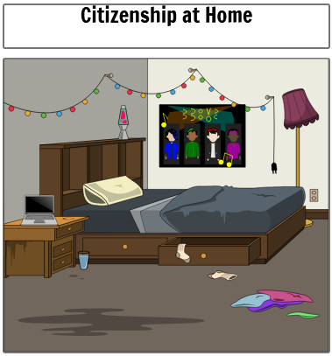

- Clean my room
- Stay up late
- Play video games
- Sleep
- Do my schoolwork
- Sing-along with music

Rights Responsibilities Privileges
________________ _________________ ________________
________________ _________________ ________________
________________ _________________ ________________
________________ _________________ ________________

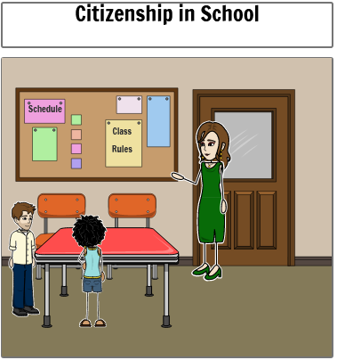

- Listen to the teacher
- Ask questions
- Receive a homework pass
- Do my work
- Obey classroom rules
- Participate in discussions
- Be a table leader

Rights Responsibilities Privileges
________________ _________________ ________________
________________ _________________ ________________
________________ _________________ ________________
________________ _________________ ________________

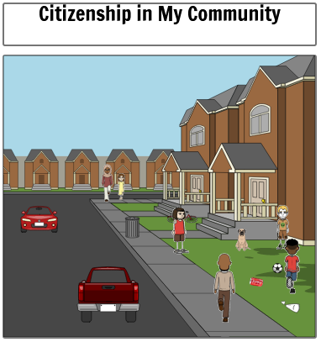

- Play sports
- Pick up my trash
- Help others
- Respect my neighbors
- Keep my dog on a leash
- Choose my friends
- Own a pet

Rights Responsibilities Privileges
________________ _________________ ________________
________________ _________________ ________________
________________ _________________ ________________
________________ _________________ ________________

