Social Studies Home Learning Activities
Standard Benchmark  Civics 2b | Students will understand that the functioning of the American government is a dynamic process which combines the formal balances of power incorporated in the Constitution with traditions, precedents, and interpretations which have evolved over time.
Grade Band | 9-12
Vocabulary/Key Concepts | dynamic, precedent, interpretation, tradition, constrain, disability, inability,

Words You Will Need to Know
- Constrain - restrict the scope, extent, or activity of
- Disability - a physical or mental condition that limits a person's movements, senses, or activities
- Dynamic – something characterized by constant change, activity, or progress.
- Inability - the state of being unable to do something
- Interpretation – a way of explaining or understanding something
- Precedent - an earlier event or action that is regarded as an example or guide to be considered in subsequent similar circumstances
- Tradition – a custom or belief passed down from generation to generation

Activity 1: Building Background Knowledge
Governments in Times of Emergencies
A pandemic is just one example of numerous types of national emergencies that might destabilize any government. Invasions and terrorist attacks are other examples. Can you think of others?
These emergencies raise awareness of the need for change. Government officials often respond to emergencies with new policies that they hope will reduce the dangers that come with the crises. There have been a lot of these new policies lately. The various levels (local, state, and federal) and branches (legislative, executive, judicial) of governments in the United States have issued stay at home orders, closed schools and “non-essential” businesses, prohibited gatherings of more than 10 people, stopped residents of one state from travelling to other states, and prohibited people from certain areas of the world from entering the United States. In Delaware, meetings of our state legislature have been postponed to support social distancing policies, and Legislative Hall where state laws are made remains closed until further notice.
This ability to change or be “dynamic” is an extremely important characteristic of any government. If a government cannot or does not change in ways that (1) adapt to new circumstances, (2) respond to changes in what citizens want, and/or (3) cope with national emergencies…its chances for survival are pretty dismal.
But, too much change can be equally destabilizing. If citizens believe that proposed or enacted changes involve risks that are unreasonable or exceed those brought on by an emergency, or that the changes pose threats to individual rights or happiness, resistance or worse may follow. The trick, as the Goldilocks Principle suggests, is finding solutions that are “just right” - not too extreme.
The authors of our Constitution understood the need to devise a dynamic government that…
- …allows change to occur. For example, they included Article V which allows the Constitution to be amended i.e. changed.
- …limits the amount to change that can occur. For example, they incorporated the Bill of Rights to ensure that government cannot constitutionally take actions that deny citizens their legitimate individual rights.
- …is equipped to respond reasonably well to potentially destabilizing changes. For example, they separated government into three branches so that one branch can always check extreme actions proposed by the other branches.
Can you think of other ways that our government might be or become dynamic?

The COVID-19 pandemic offers a reminder of one way that the authors of our Constitution anticipated and planned for emergencies that could destabilize our federal government. After deciding to have an executive branch, they asked themselves – what should happen if a sitting President fell ill and suffered, in their words, an “inability” or “disability”?
Fortunately, this has not happened in the United States during the COVID-19 pandemic. However, that has not been the case elsewhere. Several world leaders have contracted the virus. See their images and the areas they preside over illustrated in Figure 1 below. Do you recognize any of them, or the countries they serve?
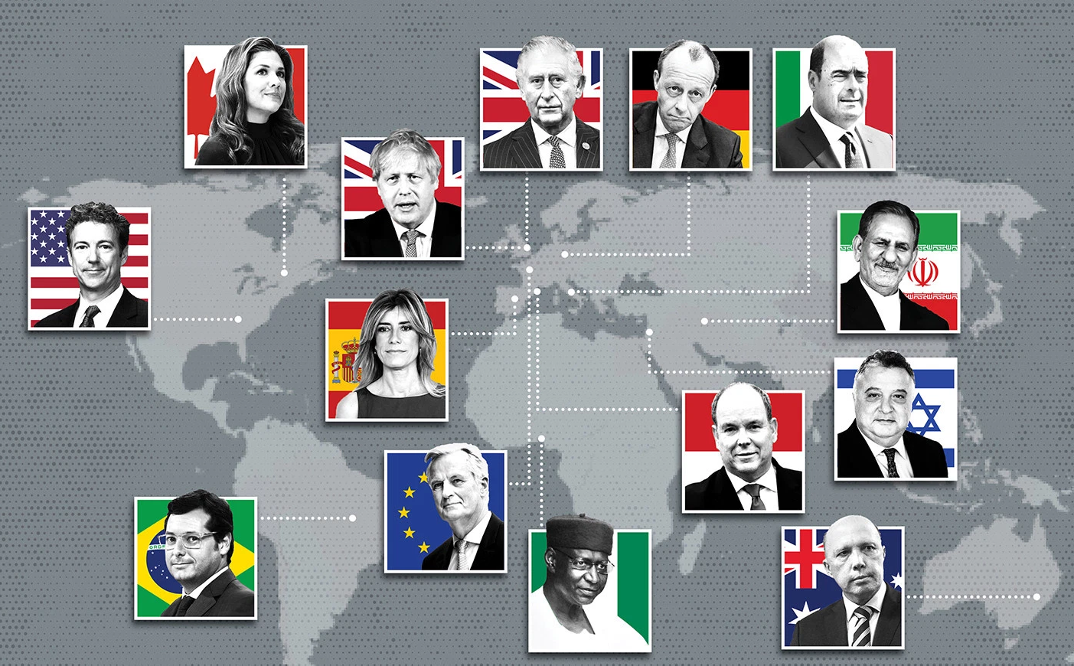
Figure 1 Source: https://foreignpolicy.com/2020/03/18/coronavirus-corridors-power-which-world-leaders-have-covid-19/
While most of the affected leaders have symptoms that have not disabled, Prime Minister Boris Johnson (United Kingdom) was placed in intensive care and had to turn over his duties to his Foreign Minister on April 6th. Thankfully, he appears to be on the road to recovery but only after his disability triggered considerable angst throughout Britain.
It is a bit unsettling but also wise to remember that germs do not discriminate by status, wealth, race, gender, or age. No one, to our knowledge, is yet immune.
The important point for purposes of this activity is that presidential disabilities have unfolded over the course of United States history as our Founding Fathers anticipated. And, they will likely happen again.
Activity 2: Document Analysis
So how did the authors of our Constitution plan for possibility of presidential disabilities? Did they do it in a manner that created the kind of dynamic government that is “just right” for such emergencies?
Here is what they wrote…their plan:
Article II, Section 1, Clause 6. United States Constitution (ratified June 21, 1788)
“In Case of the Removal of the President from Office, or of his Death, Resignation, or Inability to discharge the Powers and Duties of the said Office, the Same shall devolve on the Vice President, and the Congress may by Law provide for the Case of Removal, Death, Resignation or Inability, both of the President and Vice President, declaring what Officer shall then act as President, and such Officer shall act accordingly, until the Disability be removed, or a President shall be elected.”

Comprehension Check
- How does this clause make it possible for the American government to survive extreme changes or emergencies?

- How does this clause in our Constitution offer evidence of the claim that government in the United States can be dynamic?

- Describe one way that this clause allows change to take place?

- Describe one way that this clause constrains change or helps ensure that it happens in ways that are “just right”.

Evaluate the Clarity of the Clause: Is it clear enough if a disability emergency arises?
Directions: Evaluate Article II, Section 1, Clause 6 of the Constitution for clarity. If an emergency does occur, which parts are clear, which parts are unclear?
QUESTION | CLARITY  Is the Constitution clear or unclear on this? (Circle one) | EVIDENCE FROM THE TEXT  If clear, what wording in Article II, Section 1, Clause 6 provides the clarity?
1- Who takes over the duties of the President if he or she dies while in office? | Clear Unclear
2- Who takes over the duties of the President if he or she resigns as President? | Clear Unclear
3-Who takes over the duties of the President in the event of a disability or an inability? | Clear Unclear
4-What counts as a disability? | Clear Unclear
5-What counts as an inability? | Clear Unclear
6-Must a disability or inability last a certain length of time before a President’s powers can be removed? | Clear Unclear
7-Who has the authority to decide whether a President has a disability or inability? | Clear Unclear
8-Can a president declare himself or herself “able” again? | Clear Unclear
9-Does the “disability clause” offer opportunities for balances of power? In other words, can one branch check another branch? | Clear Unclear
10-Does the person who takes over the duties of a disabled President become the President or is or he merely an “Acting President”? | Clear Unclear
11-Can a President who turns over his or her duties due to an inability or disability return to being the President? | Clear Unclear
12-What happens if a president suffers an inability and there is no Vice-President? | Clear Unclear
Draw a Conclusion: Was the work of the men who wrote our Constitution good enough to deal with an emergency involving a vacancy, disability, or inability in the office of the president?
Activity 3: Case Studies
The First Scare
In June of 1813 members of the United States Senate received the following note:
“[President]” James Madison is sorry that a continuance of his indisposition will not permit him to see the committee of the Senate today, nor can he at present fix a day when it will be in his power.”

Why might this note lead some to believe that there might be a national emergency?

Word circulated quickly around the nation’s capital that the President was suffering from a “bilious fever” and that death was possible! Members of Congress began thinking about Article II, Section 1, Clause 6 of the Constitution.
On July 2nd relief arrived. Madison’s wife Dolley wrote that the President’s fever broke. He slowly began resuming his duties on July 7, 1813…three weeks after the fever set in. A pretty long time for what some might consider a disability to last.

It is worth noting here that President James Madison’s two terms are memorable for a number of reasons. Among them - two of his Vice-Presidents died while in office – George Clinton and Elbridge Gerry. President Madison had no Vice-President for a total of three years!
Whew, our government survived and the nation considered itself pretty lucky.

Luck Runs Out : Things Get Dynamic Quickly and There is No Precedent
On 4 April 1841, exactly thirty days after becoming president, sixty-nine year old President William Henry Harrison – so delirious in his final hour that he spoke to his doctor as if he was his Vice-President - died of what appears to have been pneumonia. Luck had run out.
John Adams, who once served as George Washington’s Vice-President once said, “"I am Vice President. In this I am nothing, but I may be everything."
Like Adams, Harrison’s Vice-President John Tyler thought so little of his position that he left the nation’s capital after Harrison’s inauguration and was now 230 miles or at least 21 hours away at his home in Richmond, Virginia. Remember, there were no phones, no telegraph, and no internet in 1841. And now, there was no President and no precedent. Harrison was the first President to die or have to be removed while in office – the first to leave the Office of the President vacant. The nation was now without a head. Things were pretty dynamic all of a sudden. This would be the first real test of Article II, Section 1, Clause 6.
Secretary of State Daniel Webster called a meeting of the President’s Cabinet. They sent two men by carriage, then train, then boat to John Tyler’s home and notify him of the President’s death. They arrived at dawn and told the Vice-President what happened. Clearly stunned by the news, Tyler said, “My God, the President is dead!”
Adding to the emergency, Tyler’s wife was gravely ill, partially paralyzed, and he had seven children at home.

Activity 4: Thought Exercise
Before moving on to the next section, pretend for a few minutes that you are Vice-President John Tyler. What do you do? What steps will you take to deal with this national emergency…to ensure that our government survives this emergency? Remember, this is one that the nation has never faced. And there is no precedent to guide your decisions. You are about to set one.
Questions to Consider: Does Article II, Section 6, Clause 1 of the Constitution help you deal with the emergency? How?
Does it constrain your decisions? How? Are you now President of the United States?

Tyler’s Decisions
Probably hoping to leave little doubt that the crisis was under controlthat the American government would continue, that the country was in good hands, and that there would be a smooth transition of power, Vice-President John Tyler took the following steps:
- He returned to Washington almost immediately with two of his sons arriving on April 6th
- He immediately had a federal judge administer the presidential oath of office
- He called members of his cabinet into a meeting
- He told his Cabinet, “I, as president, will be responsible for my administration.”
- He delivered an inaugural address on April 14th and moved into the White House
The following statement appeared in the New Your American newspaper on April 16th:
“It is impossible for an American not to feel…great pride at the quiet, orderly, and, as it were, matter of course transition, by which so important a movement has been operated.”

Acting decisively, John Tyler declared himself President of the United States.
How well do you think Tyler handled the emergency? Were his actions constitutional?

What About the Balance of Power?
Recall that there are three branches that make-up the federal government – executive, legislative, judicial. The men who wrote the Constitution did this so that the branches could always check one another if they appeared to be abusing their powers. The emergency that our government now faced was situated in the executive branch. Any decision that John Tyler (or you pretending to be him) might make could be checked by Congress.
Here is what John Quincy Adams who was serving in Congress wrote:
“…it [Tyler’s interpretation of the Constitution] is a construction in direct violation both of the grammar and context of the Constitution, which confers upon the Vice-President, on the decease of the President, not the office, but the powers and duties of the said office.”
While others agreed with Adams, the House voted 38-8 to call Tyler “President of the United States.” A precedent was set.

So, does this mean that all Vice-Presidents following John Tyler are constrained if a President dies while in office? Or, is our government still “dynamic” in such situations?
And what if a different type of emergency arises e.g. a president exhibits an “inability” or “disability”? Does he or she become President?

Did Our Presidential Emergencies End with President Harrison’s Death? Not by this count…7-1-6 and 3
Seven other Presidents since William Henry Harrison died while in office.
- Zachary Taylor
- Abraham Lincoln
- James Garfield
- William McKinley
- Warren Harding
- Franklin Delano Roosevelt
- John Kennedy
One President resigned.
- Richard Nixon
At least six Presidents were disabled for varying lengths of time including Woodrow Wilson . Ins some cases the public was unaware of the disabilities.
- Abraham Lincoln
- James Garfield
- Woodrow Wilson
- Franklin Roosevelt
- Dwight Eisenhower
- Lyndon Johnson
On three occasions Presidents voluntarily turned over the duties of the Presidency for relatively minor events.
- Ronald Reagan
- George W. Bush twice (went under anesthesia for colonoscopies)

Sources
Feerick, John D. (1965) From Failing Hands: The Story of Presidential Succession
Feerick, John D. (2014) The Twenty Fifth Amendment: Its complete history and applications. . (Third Edition)
Cohen, Jared (2019). Accidental Presidents: Eight Men Who Changed America.
Coronavirus in the Corridors of Power: which politicians and senior officials have the Coronavirus? Accessed at https://foreignpolicy.com/2020/03/18/coronavirus-corridors-power-which-world-leaders-have-covid-19/

